**Resultados Fioretti**

**Tabela 1.** Caracterização da amostra estudada.

|  |  |
| --- | --- |
|  | Summary |
| Tamanho da amostra | 4,263 |
| Idade, média ± dp | 60.3 ± 14.1 |
| Sexo |  |
| Masculino | 1,217 (28.6%) |
| Feminino | 3,045 (71.4%) |
| Hipertensão Arterial (HAS) |  |
| Não | 2,668 (62.6%) |
| Sim | 1,594 (37.4%) |
| Diabetes Mellitus (DM) |  |
| Não | 3,359 (78.8%) |
| Sim | 903 (21.2%) |
| Tabagismo |  |
| Não | 3,784 (88.8%) |
| Sim | 478 (11.2%) |
| Dislipidemia |  |
| Não | 3,592 (84.3%) |
| Sim | 668 (15.7%) |
| Doença Carotídea (USG) |  |
| Não | 2,445 (57.4%) |
| Sim | 1,817 (42.6%) |
| Estenose |  |
| Ausência | 2,445 (57.4%) |
| Espessamento | 318 (7.5%) |
| Estenose <50% | 1,431 (33.6%) |
| Estenose 50-69% | 31 (0.7%) |
| Estesone >70% | 22 (0.5%) |
| Sub-oclusão | 15 (0.4%) |
| Glicose, média ± dp | 96.2 ± 24.7 |
| Triglicérides, média ± dp | 117.0 ± 61.0 |
| Índice TyG, média ± dp | 4.6 ± 0.3 |
| PCR, média ± dp | 3.1 ± 9.1 |
| HDL, média ± dp | 55.6 ± 15.1 |
| PCR/HDL, média ± dp | 6.2 ± 18.3 |

# Determinar sensibilidade e especificidade (capacidade preditiva) do índice TyG com doença carotídea.

**Tabela 2.** Sensibilidade e especificidade do TyG para diagnóstico de doença carotídea.

|  |  |  |  |  |  |
| --- | --- | --- | --- | --- | --- |
| Cutpoint | Sensitivity | Specificity | classified | LR+ | LR- |
| >= 2.5 | 100.00% | 0.00% | 42.63% | 1.0000 |  |
| >= 4 | 99.94% | 0.00% | 42.61% | 0.9994 |  |
| >= 4.1 | 99.89% | 0.45% | 42.84% | 1.0034 | 0.2447 |
| >= 4.2 | 99.23% | 3.15% | 44.11% | 1.0246 | 0.2447 |
| >= 4.3 | 96.97% | 9.12% | 46.57% | 1.0671 | 0.3319 |
| >= 4.4 | 90.31% | 20.49% | 50.26% | 1.1359 | 0.4727 |
| >= 4.5 | 78.76% | 35.75% | 54.08% | 1.2257 | 0.5943 |
| >= 4.6 | 64.50% | 51.45% | 57.02% | 1.3286 | 0.6899 |
| >= 4.7 | 48.60% | 66.09% | 58.63% | 1.4333 | 0.7777 |
| >= 4.8 | 33.08% | 78.16% | 58.94% | 1.5145 | 0.8562 |
| >= 4.9 | 20.58% | 86.71% | 58.52% | 1.5485 | 0.9159 |
| >= 5 | 12.05% | 93.29% | 58.66% | 1.7969 | 0.9427 |
| >= 5.1 | 6.66% | 96.69% | 58.31% | 2.0101 | 0.9654 |
| >= 5.2 | 3.69% | 98.08% | 57.84% | 1.9182 | 0.9820 |
| >= 5.3 | 2.04% | 98.85% | 57.58% | 1.7781 | 0.9910 |
| >= 5.4 | 0.99% | 99.22% | 57.34% | 1.2748 | 0.9978 |
| >= 5.5 | 0.61% | 99.63% | 57.41% | 1.6446 | 0.9976 |
| >= 5.6 | 0.39% | 99.71% | 57.37% | 1.3456 | 0.9990 |
| >= 5.7 | 0.33% | 99.80% | 57.39% | 1.6148 | 0.9987 |
| >= 5.8 | 0.17% | 99.84% | 57.34% | 1.0092 | 1.0000 |
| >= 5.9 | 0.06% | 99.88% | 57.32% | 0.4485 | 1.0007 |
| >= 6 | 0.00% | 99.92% | 57.32% | 0.0000 | 1.0008 |
| >= 6.1 | 0.00% | 99.96% | 57.34% | 0.0000 | 1.0004 |
| > 6.1 | 0.00% | 100.00% | 57.37% | 1.0000 |  |

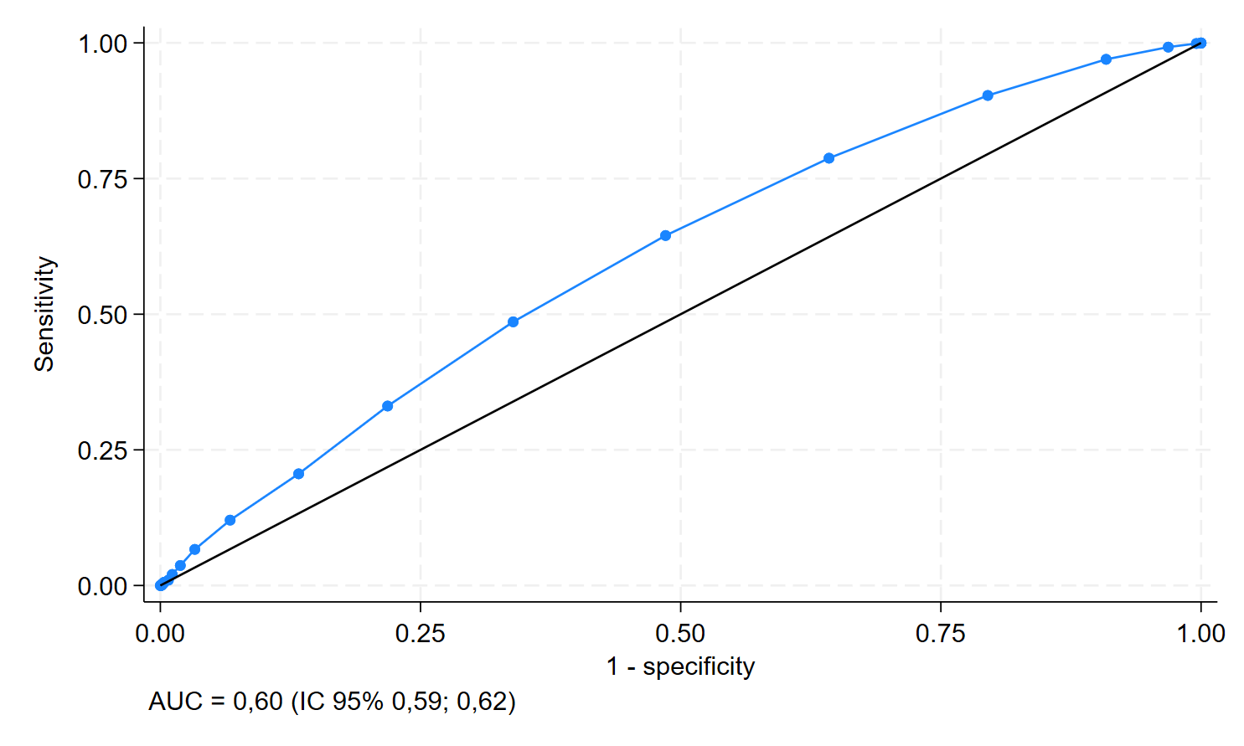**Figura 1.** Curva ROC (Received Operating Curve) da capacidade preditiva do índice TyG para diagnóstico de doença carotídea.

# Gráfico, Gráfico de linhas Descrição gerada automaticamenteDeterminar a relação da gravidade da doença carotídea com índice TyG.

**Figura 2.** Associação da gravidade da doença carotídea com o índice TyG.

# Determinar se a associação de um ou mais fatores de risco com TyG é capaz de prever a existência de doença carotídea e sua gravidade.

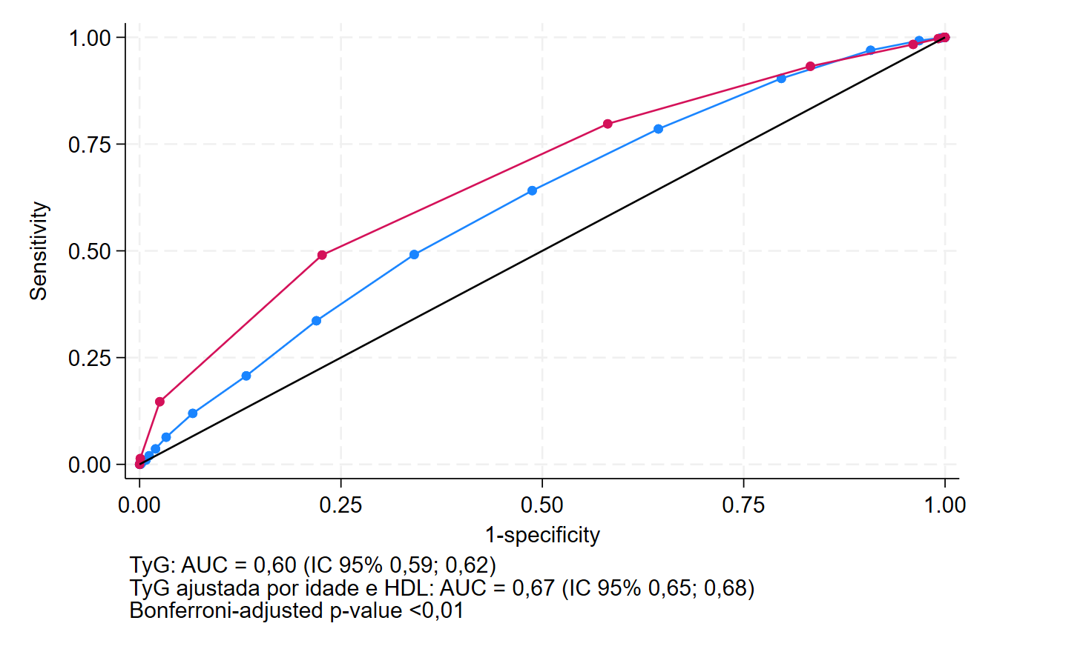

**Figura 3.** Associação da presença de doença carotídea com o índice TyG ajustado por fatores de risco (Idade e HDL).

# Determinar sensibilidade e especificidade do PCR/HDL para diagnóstico de doença carotídea.

**Tabela 3.** Sensibilidade e especificidade do PCR/HDL para diagnóstico de doença carotídea.

|  |  |  |  |  |  |
| --- | --- | --- | --- | --- | --- |
| Cutpoint | Sensitivity | Specificity | classified | LR+ | LR- |
|  |  |  |  |  |  |
| ( >= 0 ) | 100.00% | 0.00% | 42.40% | 1.0000 |  |
| ( >= .1 ) | 99.78% | 0.00% | 42.30% | 0.9978 |  |
| ( >= .2 ) | 95.54% | 4.24% | 42.95% | 0.9977 | 1.0511 |
| ( >= .3 ) | 92.72% | 8.24% | 44.06% | 1.0104 | 0.8838 |
| ( >= .4 ) | 89.57% | 12.64% | 45.25% | 1.0252 | 0.8255 |
| ( >= .5 ) | 86.52% | 16.08% | 45.94% | 1.0310 | 0.8382 |
| ( >= .6 ) | 83.48% | 19.60% | 46.68% | 1.0383 | 0.8429 |
| ( >= .7 ) | 79.89% | 22.40% | 46.77% | 1.0295 | 0.8977 |
| ( >= .8 ) | 78.26% | 25.36% | 47.79% | 1.0485 | 0.8572 |
| ( >= .9 ) | 75.33% | 28.16% | 48.16% | 1.0485 | 0.8762 |
| ( >= 1 ) | 72.61% | 30.88% | 48.57% | 1.0505 | 0.8870 |
| ( >= 1.1 ) | 70.00% | 32.88% | 48.62% | 1.0429 | 0.9124 |
| ( >= 1.2 ) | 68.04% | 34.72% | 48.85% | 1.0423 | 0.9204 |
| ( >= 1.3 ) | 66.52% | 36.88% | 49.45% | 1.0539 | 0.9078 |
| ( >= 1.4 ) | 63.91% | 39.20% | 49.68% | 1.0512 | 0.9206 |
| ( >= 1.5 ) | 62.72% | 40.48% | 49.91% | 1.0537 | 0.9210 |
| ( >= 1.6 ) | 61.09% | 41.92% | 50.05% | 1.0518 | 0.9283 |
| ( >= 1.7 ) | 59.57% | 43.68% | 50.41% | 1.0576 | 0.9257 |
| ( >= 1.8 ) | 58.15% | 45.44% | 50.83% | 1.0658 | 0.9209 |
| ( >= 1.9 ) | 56.96% | 46.96% | 51.20% | 1.0738 | 0.9166 |
| ( >= 2 ) | 55.98% | 48.08% | 51.43% | 1.0782 | 0.9156 |
| ( >= 2.1 ) | 54.78% | 48.80% | 51.34% | 1.0700 | 0.9266 |
| ( >= 2.2 ) | 53.15% | 50.32% | 51.52% | 1.0699 | 0.9310 |
| ( >= 2.3 ) | 51.85% | 51.84% | 51.84% | 1.0766 | 0.9289 |
| ( >= 2.4 ) | 50.65% | 53.44% | 52.26% | 1.0879 | 0.9234 |
| ( >= 2.5 ) | 49.02% | 54.80% | 52.35% | 1.0846 | 0.9303 |
| ( >= 2.6 ) | 47.93% | 55.76% | 52.44% | 1.0835 | 0.9337 |
| ( >= 2.7 ) | 46.41% | 57.04% | 52.53% | 1.0804 | 0.9395 |
| ( >= 2.8 ) | 46.20% | 58.16% | 53.09% | 1.1041 | 0.9251 |
| ( >= 2.9 ) | 45.76% | 58.72% | 53.23% | 1.1085 | 0.9237 |
| ( >= 3 ) | 44.67% | 60.08% | 53.55% | 1.1191 | 0.9209 |
| ( >= 3.1 ) | 44.13% | 61.44% | 54.10% | 1.1445 | 0.9093 |
| ( >= 3.2 ) | 43.04% | 62.24% | 54.10% | 1.1399 | 0.9151 |
| ( >= 3.3 ) | 42.50% | 62.88% | 54.24% | 1.1449 | 0.9144 |
| ( >= 3.4 ) | 41.74% | 63.52% | 54.29% | 1.1442 | 0.9172 |
| ( >= 3.5 ) | 40.98% | 64.32% | 54.42% | 1.1485 | 0.9176 |
| ( >= 3.6 ) | 40.76% | 65.12% | 54.79% | 1.1686 | 0.9097 |
| ( >= 3.7 ) | 39.89% | 65.60% | 54.70% | 1.1596 | 0.9163 |
| ( >= 3.8 ) | 39.02% | 66.24% | 54.70% | 1.1559 | 0.9206 |
| ( >= 3.9 ) | 38.37% | 67.20% | 54.98% | 1.1698 | 0.9171 |
| ( >= 4 ) | 37.39% | 68.24% | 55.16% | 1.1773 | 0.9175 |
| ( >= 4.1 ) | 37.07% | 69.12% | 55.53% | 1.2003 | 0.9105 |
| ( >= 4.2 ) | 35.98% | 69.68% | 55.39% | 1.1866 | 0.9188 |
| ( >= 4.3 ) | 35.22% | 70.32% | 55.44% | 1.1866 | 0.9213 |
| ( >= 4.4 ) | 34.78% | 70.88% | 55.58% | 1.1945 | 0.9201 |
| ( >= 4.5 ) | 34.13% | 71.44% | 55.62% | 1.1950 | 0.9220 |
| ( >= 4.6 ) | 33.70% | 72.00% | 55.76% | 1.2034 | 0.9209 |
| ( >= 4.7 ) | 33.15% | 72.48% | 55.81% | 1.2047 | 0.9223 |
| ( >= 4.8 ) | 32.28% | 73.12% | 55.81% | 1.2010 | 0.9261 |
| ( >= 4.9 ) | 31.30% | 73.76% | 55.76% | 1.1930 | 0.9313 |
| ( >= 5 ) | 30.65% | 74.24% | 55.76% | 1.1899 | 0.9341 |
| ( >= 5.1 ) | 30.11% | 74.88% | 55.90% | 1.1986 | 0.9334 |
| ( >= 5.2 ) | 29.89% | 75.04% | 55.90% | 1.1976 | 0.9343 |
| ( >= 5.3 ) | 29.13% | 75.44% | 55.81% | 1.1861 | 0.9394 |
| ( >= 5.4 ) | 28.91% | 75.84% | 55.94% | 1.1967 | 0.9373 |
| ( >= 5.5 ) | 28.48% | 76.40% | 56.08% | 1.2067 | 0.9361 |
| ( >= 5.6 ) | 27.83% | 77.12% | 56.22% | 1.2162 | 0.9359 |
| ( >= 5.7 ) | 27.28% | 77.44% | 56.18% | 1.2093 | 0.9390 |
| ( >= 5.8 ) | 27.17% | 77.52% | 56.18% | 1.2088 | 0.9394 |
| ( >= 5.9 ) | 26.30% | 77.60% | 55.85% | 1.1743 | 0.9497 |
| ( >= 6 ) | 25.33% | 77.92% | 55.62% | 1.1470 | 0.9583 |
| ( >= 6.1 ) | 24.57% | 78.16% | 55.44% | 1.1248 | 0.9651 |
| ( >= 6.2 ) | 24.57% | 78.32% | 55.53% | 1.1331 | 0.9632 |
| ( >= 6.3 ) | 24.02% | 78.48% | 55.39% | 1.1163 | 0.9681 |
| ( >= 6.4 ) | 23.48% | 79.04% | 55.48% | 1.1201 | 0.9681 |
| ( >= 6.5 ) | 23.15% | 79.44% | 55.58% | 1.1261 | 0.9674 |
| ( >= 6.6 ) | 23.04% | 79.76% | 55.71% | 1.1385 | 0.9649 |
| ( >= 6.7 ) | 22.39% | 79.84% | 55.48% | 1.1107 | 0.9721 |
| ( >= 6.8 ) | 22.39% | 80.24% | 55.71% | 1.1332 | 0.9672 |
| ( >= 6.9 ) | 21.63% | 80.80% | 55.71% | 1.1266 | 0.9699 |
| ( >= 7 ) | 21.41% | 80.96% | 55.71% | 1.1246 | 0.9707 |
| ( >= 7.1 ) | 21.30% | 81.20% | 55.81% | 1.1332 | 0.9692 |
| ( >= 7.2 ) | 20.98% | 81.44% | 55.81% | 1.1303 | 0.9703 |
| ( >= 7.3 ) | 20.98% | 81.52% | 55.85% | 1.1352 | 0.9694 |
| ( >= 7.4 ) | 20.87% | 81.76% | 55.94% | 1.1442 | 0.9678 |
| ( >= 7.5 ) | 20.22% | 82.08% | 55.85% | 1.1282 | 0.9720 |
| ( >= 7.6 ) | 19.89% | 82.24% | 55.81% | 1.1200 | 0.9741 |
| ( >= 7.7 ) | 19.78% | 82.56% | 55.94% | 1.1343 | 0.9716 |
| ( >= 7.8 ) | 19.67% | 82.80% | 56.04% | 1.1438 | 0.9701 |
| ( >= 7.9 ) | 19.02% | 83.28% | 56.04% | 1.1377 | 0.9724 |
| ( >= 8 ) | 18.80% | 83.36% | 55.99% | 1.1301 | 0.9740 |
| ( >= 8.1 ) | 18.37% | 83.68% | 55.99% | 1.1256 | 0.9755 |
| ( >= 8.2 ) | 17.83% | 83.76% | 55.81% | 1.0977 | 0.9811 |
| ( >= 8.3 ) | 17.17% | 84.24% | 55.81% | 1.0897 | 0.9832 |
| ( >= 8.4 ) | 16.74% | 84.64% | 55.85% | 1.0898 | 0.9837 |
| ( >= 8.5 ) | 16.63% | 84.72% | 55.85% | 1.0884 | 0.9841 |
| ( >= 8.6 ) | 16.63% | 84.88% | 55.94% | 1.0999 | 0.9822 |
| ( >= 8.7 ) | 16.41% | 85.20% | 56.04% | 1.1090 | 0.9811 |
| ( >= 8.8 ) | 15.98% | 85.28% | 55.90% | 1.0855 | 0.9852 |
| ( >= 8.9 ) | 15.87% | 85.28% | 55.85% | 1.0781 | 0.9865 |
| ( >= 9 ) | 15.87% | 85.52% | 55.99% | 1.0960 | 0.9838 |
| ( >= 9.1 ) | 15.76% | 85.68% | 56.04% | 1.1006 | 0.9832 |
| ( >= 9.2 ) | 15.54% | 85.84% | 56.04% | 1.0977 | 0.9839 |
| ( >= 9.3 ) | 15.43% | 85.92% | 56.04% | 1.0962 | 0.9842 |
| ( >= 9.4 ) | 15.33% | 86.08% | 56.08% | 1.1010 | 0.9837 |
| ( >= 9.5 ) | 15.33% | 86.24% | 56.18% | 1.1138 | 0.9818 |
| ( >= 9.6 ) | 15.11% | 86.24% | 56.08% | 1.0980 | 0.9844 |
| ( >= 9.7 ) | 15.11% | 86.32% | 56.13% | 1.1044 | 0.9834 |
| ( >= 9.8 ) | 15.00% | 86.56% | 56.22% | 1.1161 | 0.9820 |
| ( >= 9.9 ) | 14.89% | 86.56% | 56.18% | 1.1080 | 0.9832 |
| ( >= 10 ) | 14.67% | 86.80% | 56.22% | 1.1117 | 0.9830 |
| ( >= 10.1 ) | 14.57% | 87.04% | 56.31% | 1.1239 | 0.9816 |
| ( >= 10.2 ) | 14.35% | 87.44% | 56.45% | 1.1423 | 0.9796 |
| ( >= 10.3 ) | 14.24% | 87.52% | 56.45% | 1.1410 | 0.9799 |
| ( >= 10.4 ) | 14.02% | 87.84% | 56.54% | 1.1531 | 0.9788 |
| ( >= 10.5 ) | 13.70% | 88.00% | 56.50% | 1.1413 | 0.9807 |
| ( >= 10.6 ) | 13.70% | 88.08% | 56.54% | 1.1490 | 0.9798 |
| ( >= 10.7 ) | 13.59% | 88.08% | 56.50% | 1.1398 | 0.9811 |
| ( >= 10.8 ) | 13.37% | 88.08% | 56.41% | 1.1216 | 0.9835 |
| ( >= 10.9 ) | 13.26% | 88.08% | 56.36% | 1.1125 | 0.9848 |
| ( >= 11 ) | 12.93% | 88.40% | 56.41% | 1.1151 | 0.9849 |
| ( >= 11.1 ) | 12.83% | 88.40% | 56.36% | 1.1057 | 0.9861 |
| ( >= 11.2 ) | 12.72% | 88.72% | 56.50% | 1.1274 | 0.9838 |
| ( >= 11.3 ) | 12.61% | 88.80% | 56.50% | 1.1258 | 0.9841 |
| ( >= 11.4 ) | 12.39% | 88.88% | 56.45% | 1.1143 | 0.9857 |
| ( >= 11.5 ) | 12.28% | 88.96% | 56.45% | 1.1126 | 0.9860 |
| ( >= 11.6 ) | 12.17% | 89.04% | 56.45% | 1.1108 | 0.9864 |
| ( >= 11.7 ) | 12.17% | 89.36% | 56.64% | 1.1442 | 0.9828 |
| ( >= 11.8 ) | 11.96% | 89.36% | 56.54% | 1.1237 | 0.9853 |
| ( >= 11.9 ) | 11.74% | 89.60% | 56.59% | 1.1288 | 0.9851 |
| ( >= 12 ) | 11.52% | 89.60% | 56.50% | 1.1079 | 0.9875 |
| ( >= 12.1 ) | 11.41% | 89.68% | 56.50% | 1.1059 | 0.9878 |
| ( >= 12.2 ) | 11.30% | 89.92% | 56.59% | 1.1215 | 0.9864 |
| ( >= 12.3 ) | 11.09% | 90.00% | 56.54% | 1.1087 | 0.9879 |
| ( >= 12.4 ) | 10.87% | 90.08% | 56.50% | 1.0957 | 0.9895 |
| ( >= 12.5 ) | 10.87% | 90.16% | 56.54% | 1.1046 | 0.9886 |
| ( >= 12.6 ) | 10.76% | 90.24% | 56.54% | 1.1025 | 0.9889 |
| ( >= 12.7 ) | 10.54% | 90.32% | 56.50% | 1.0892 | 0.9904 |
| ( >= 12.8 ) | 10.43% | 90.56% | 56.59% | 1.1054 | 0.9890 |
| ( >= 12.9 ) | 10.43% | 90.88% | 56.77% | 1.1442 | 0.9855 |
| ( >= 13 ) | 10.33% | 91.28% | 56.96% | 1.1842 | 0.9824 |
| ( >= 13.1 ) | 10.22% | 91.28% | 56.91% | 1.1717 | 0.9836 |
| ( >= 13.3 ) | 10.11% | 91.52% | 57.00% | 1.1921 | 0.9822 |
| ( >= 13.4 ) | 10.00% | 91.68% | 57.05% | 1.2019 | 0.9817 |
| ( >= 13.5 ) | 10.00% | 91.84% | 57.14% | 1.2255 | 0.9800 |
| ( >= 13.6 ) | 9.89% | 92.00% | 57.19% | 1.2364 | 0.9794 |
| ( >= 13.7 ) | 9.89% | 92.16% | 57.28% | 1.2616 | 0.9777 |
| ( >= 13.8 ) | 9.78% | 92.24% | 57.28% | 1.2606 | 0.9781 |
| ( >= 13.9 ) | 9.67% | 92.24% | 57.24% | 1.2466 | 0.9793 |
| ( >= 14 ) | 9.57% | 92.24% | 57.19% | 1.2326 | 0.9804 |
| ( >= 14.1 ) | 9.57% | 92.32% | 57.24% | 1.2455 | 0.9796 |
| ( >= 14.3 ) | 9.24% | 92.32% | 57.10% | 1.2030 | 0.9831 |
| ( >= 14.4 ) | 9.13% | 92.40% | 57.10% | 1.2014 | 0.9834 |
| ( >= 14.5 ) | 9.02% | 92.48% | 57.10% | 1.1997 | 0.9838 |
| ( >= 14.8 ) | 8.91% | 92.56% | 57.10% | 1.1980 | 0.9841 |
| ( >= 14.9 ) | 8.91% | 92.64% | 57.14% | 1.2110 | 0.9832 |
| ( >= 15.1 ) | 8.91% | 92.72% | 57.19% | 1.2243 | 0.9824 |
| ( >= 15.3 ) | 8.91% | 92.80% | 57.24% | 1.2379 | 0.9815 |
| ( >= 15.4 ) | 8.80% | 92.80% | 57.19% | 1.2228 | 0.9827 |
| ( >= 15.5 ) | 8.80% | 92.88% | 57.24% | 1.2366 | 0.9819 |
| ( >= 15.7 ) | 8.80% | 93.04% | 57.33% | 1.2650 | 0.9802 |
| ( >= 15.8 ) | 8.70% | 93.12% | 57.33% | 1.2639 | 0.9805 |
| ( >= 15.9 ) | 8.70% | 93.20% | 57.37% | 1.2788 | 0.9797 |
| ( >= 16.1 ) | 8.59% | 93.20% | 57.33% | 1.2628 | 0.9808 |
| ( >= 16.2 ) | 8.59% | 93.36% | 57.42% | 1.2932 | 0.9791 |
| ( >= 16.3 ) | 8.59% | 93.52% | 57.51% | 1.3251 | 0.9775 |
| ( >= 16.4 ) | 8.37% | 93.52% | 57.42% | 1.2916 | 0.9798 |
| ( >= 16.6 ) | 8.37% | 93.60% | 57.47% | 1.3077 | 0.9790 |
| ( >= 16.7 ) | 8.37% | 93.68% | 57.51% | 1.3243 | 0.9781 |
| ( >= 16.8 ) | 8.37% | 93.84% | 57.60% | 1.3587 | 0.9765 |
| ( >= 16.9 ) | 8.26% | 93.84% | 57.56% | 1.3411 | 0.9776 |
| ( >= 17 ) | 8.04% | 93.84% | 57.47% | 1.3058 | 0.9799 |
| ( >= 17.2 ) | 7.93% | 93.84% | 57.42% | 1.2881 | 0.9811 |
| ( >= 17.3 ) | 7.83% | 94.00% | 57.47% | 1.3043 | 0.9806 |
| ( >= 17.4 ) | 7.83% | 94.08% | 57.51% | 1.3220 | 0.9797 |
| ( >= 17.6 ) | 7.83% | 94.16% | 57.56% | 1.3401 | 0.9789 |
| ( >= 17.7 ) | 7.72% | 94.16% | 57.51% | 1.3215 | 0.9801 |
| ( >= 17.8 ) | 7.50% | 94.24% | 57.47% | 1.3021 | 0.9815 |
| ( >= 17.9 ) | 7.50% | 94.32% | 57.51% | 1.3204 | 0.9807 |
| ( >= 18 ) | 7.50% | 94.40% | 57.56% | 1.3393 | 0.9799 |
| ( >= 18.1 ) | 7.28% | 94.40% | 57.47% | 1.3005 | 0.9822 |
| ( >= 18.3 ) | 7.17% | 94.48% | 57.47% | 1.2996 | 0.9825 |
| ( >= 18.4 ) | 6.96% | 94.48% | 57.37% | 1.2602 | 0.9848 |
| ( >= 18.5 ) | 6.74% | 94.64% | 57.37% | 1.2573 | 0.9854 |
| ( >= 18.6 ) | 6.63% | 94.64% | 57.33% | 1.2370 | 0.9866 |
| ( >= 19 ) | 6.52% | 94.72% | 57.33% | 1.2352 | 0.9869 |
| ( >= 19.2 ) | 6.52% | 94.88% | 57.42% | 1.2738 | 0.9852 |
| ( >= 19.4 ) | 6.52% | 94.96% | 57.47% | 1.2940 | 0.9844 |
| ( >= 19.6 ) | 6.41% | 95.04% | 57.47% | 1.2930 | 0.9847 |
| ( >= 19.7 ) | 6.30% | 95.12% | 57.47% | 1.2919 | 0.9850 |
| ( >= 20.5 ) | 6.20% | 95.28% | 57.51% | 1.3126 | 0.9845 |
| ( >= 20.6 ) | 6.20% | 95.36% | 57.56% | 1.3353 | 0.9837 |
| ( >= 20.9 ) | 6.09% | 95.36% | 57.51% | 1.3118 | 0.9848 |
| ( >= 21.1 ) | 6.09% | 95.60% | 57.65% | 1.3834 | 0.9824 |
| ( >= 21.2 ) | 5.98% | 95.68% | 57.65% | 1.3839 | 0.9827 |
| ( >= 21.5 ) | 5.98% | 95.76% | 57.70% | 1.4100 | 0.9818 |
| ( >= 21.6 ) | 5.87% | 95.76% | 57.65% | 1.3843 | 0.9830 |
| ( >= 22.2 ) | 5.76% | 95.84% | 57.65% | 1.3848 | 0.9833 |
| ( >= 22.4 ) | 5.76% | 95.92% | 57.70% | 1.4120 | 0.9825 |
| ( >= 22.7 ) | 5.65% | 95.92% | 57.65% | 1.3853 | 0.9836 |
| ( >= 22.8 ) | 5.43% | 95.92% | 57.56% | 1.3321 | 0.9859 |
| ( >= 23 ) | 5.43% | 96.00% | 57.60% | 1.3587 | 0.9851 |
| ( >= 23.3 ) | 5.43% | 96.08% | 57.65% | 1.3864 | 0.9842 |
| ( >= 23.4 ) | 5.33% | 96.08% | 57.60% | 1.3587 | 0.9854 |
| ( >= 23.6 ) | 5.22% | 96.08% | 57.56% | 1.3310 | 0.9865 |
| ( >= 23.9 ) | 5.22% | 96.16% | 57.60% | 1.3587 | 0.9857 |
| ( >= 24 ) | 5.11% | 96.16% | 57.56% | 1.3304 | 0.9868 |
| ( >= 24.1 ) | 5.00% | 96.16% | 57.51% | 1.3021 | 0.9879 |
| ( >= 24.4 ) | 4.89% | 96.16% | 57.47% | 1.2738 | 0.9891 |
| ( >= 24.5 ) | 4.89% | 96.24% | 57.51% | 1.3009 | 0.9882 |
| ( >= 24.8 ) | 4.89% | 96.32% | 57.56% | 1.3292 | 0.9874 |
| ( >= 25.2 ) | 4.89% | 96.40% | 57.60% | 1.3587 | 0.9866 |
| ( >= 25.4 ) | 4.89% | 96.48% | 57.65% | 1.3896 | 0.9858 |
| ( >= 25.6 ) | 4.78% | 96.48% | 57.60% | 1.3587 | 0.9869 |
| ( >= 25.8 ) | 4.67% | 96.48% | 57.56% | 1.3278 | 0.9880 |
| ( >= 25.9 ) | 4.67% | 96.56% | 57.60% | 1.3587 | 0.9872 |
| ( >= 26 ) | 4.57% | 96.56% | 57.56% | 1.3271 | 0.9883 |
| ( >= 26.4 ) | 4.57% | 96.64% | 57.60% | 1.3587 | 0.9875 |
| ( >= 26.6 ) | 4.46% | 96.64% | 57.56% | 1.3263 | 0.9887 |
| ( >= 26.9 ) | 4.35% | 96.80% | 57.60% | 1.3587 | 0.9881 |
| ( >= 27 ) | 4.24% | 96.80% | 57.56% | 1.3247 | 0.9893 |
| ( >= 27.4 ) | 4.24% | 96.88% | 57.60% | 1.3587 | 0.9884 |
| ( >= 27.5 ) | 4.13% | 97.04% | 57.65% | 1.3954 | 0.9879 |
| ( >= 27.8 ) | 4.02% | 97.04% | 57.60% | 1.3587 | 0.9891 |
| ( >= 27.9 ) | 3.91% | 97.12% | 57.60% | 1.3587 | 0.9894 |
| ( >= 28 ) | 3.91% | 97.20% | 57.65% | 1.3975 | 0.9885 |
| ( >= 28.2 ) | 3.91% | 97.28% | 57.70% | 1.4386 | 0.9877 |
| ( >= 28.3 ) | 3.80% | 97.28% | 57.65% | 1.3987 | 0.9889 |
| ( >= 28.6 ) | 3.80% | 97.36% | 57.70% | 1.4410 | 0.9880 |
| ( >= 29.6 ) | 3.70% | 97.36% | 57.65% | 1.3999 | 0.9892 |
| ( >= 29.7 ) | 3.59% | 97.36% | 57.60% | 1.3587 | 0.9903 |
| ( >= 30.1 ) | 3.48% | 97.36% | 57.56% | 1.3175 | 0.9914 |
| ( >= 30.2 ) | 3.37% | 97.36% | 57.51% | 1.2764 | 0.9925 |
| ( >= 31.4 ) | 3.37% | 97.44% | 57.56% | 1.3162 | 0.9917 |
| ( >= 31.5 ) | 3.37% | 97.52% | 57.60% | 1.3587 | 0.9909 |
| ( >= 31.8 ) | 3.26% | 97.60% | 57.60% | 1.3587 | 0.9912 |
| ( >= 32.4 ) | 3.15% | 97.60% | 57.56% | 1.3134 | 0.9923 |
| ( >= 32.6 ) | 3.04% | 97.60% | 57.51% | 1.2681 | 0.9934 |
| ( >= 33.4 ) | 2.93% | 97.60% | 57.47% | 1.2228 | 0.9945 |
| ( >= 33.5 ) | 2.93% | 97.68% | 57.51% | 1.2650 | 0.9937 |
| ( >= 34.6 ) | 2.93% | 97.76% | 57.56% | 1.3102 | 0.9929 |
| ( >= 34.7 ) | 2.83% | 97.76% | 57.51% | 1.2616 | 0.9940 |
| ( >= 35 ) | 2.83% | 97.92% | 57.60% | 1.3587 | 0.9924 |
| ( >= 35.9 ) | 2.83% | 98.00% | 57.65% | 1.4130 | 0.9916 |
| ( >= 36.9 ) | 2.72% | 98.00% | 57.60% | 1.3587 | 0.9927 |
| ( >= 37.3 ) | 2.72% | 98.08% | 57.65% | 1.4153 | 0.9919 |
| ( >= 37.5 ) | 2.72% | 98.16% | 57.70% | 1.4768 | 0.9911 |
| ( >= 38 ) | 2.61% | 98.16% | 57.65% | 1.4178 | 0.9922 |
| ( >= 38.2 ) | 2.61% | 98.24% | 57.70% | 1.4822 | 0.9914 |
| ( >= 40.8 ) | 2.50% | 98.24% | 57.65% | 1.4205 | 0.9925 |
| ( >= 41.2 ) | 2.39% | 98.24% | 57.60% | 1.3587 | 0.9936 |
| ( >= 41.4 ) | 2.28% | 98.32% | 57.60% | 1.3587 | 0.9939 |
| ( >= 41.5 ) | 2.17% | 98.32% | 57.56% | 1.2940 | 0.9950 |
| ( >= 45.3 ) | 2.07% | 98.32% | 57.51% | 1.2293 | 0.9961 |
| ( >= 47.1 ) | 2.07% | 98.40% | 57.56% | 1.2908 | 0.9953 |
| ( >= 48.2 ) | 1.96% | 98.40% | 57.51% | 1.2228 | 0.9964 |
| ( >= 48.3 ) | 1.85% | 98.40% | 57.47% | 1.1549 | 0.9975 |
| ( >= 48.6 ) | 1.85% | 98.48% | 57.51% | 1.2157 | 0.9967 |
| ( >= 49.8 ) | 1.85% | 98.56% | 57.56% | 1.2832 | 0.9959 |
| ( >= 51.6 ) | 1.74% | 98.56% | 57.51% | 1.2077 | 0.9970 |
| ( >= 54.6 ) | 1.63% | 98.56% | 57.47% | 1.1322 | 0.9981 |
| ( >= 55.4 ) | 1.63% | 98.64% | 57.51% | 1.1988 | 0.9973 |
| ( >= 57.5 ) | 1.63% | 98.72% | 57.56% | 1.2738 | 0.9965 |
| ( >= 57.9 ) | 1.63% | 98.80% | 57.60% | 1.3587 | 0.9956 |
| ( >= 58.7 ) | 1.63% | 98.88% | 57.65% | 1.4557 | 0.9948 |
| ( >= 60.7 ) | 1.63% | 98.96% | 57.70% | 1.5677 | 0.9940 |
| ( >= 60.9 ) | 1.63% | 99.04% | 57.74% | 1.6984 | 0.9932 |
| ( >= 62.4 ) | 1.63% | 99.12% | 57.79% | 1.8528 | 0.9924 |
| ( >= 62.5 ) | 1.52% | 99.12% | 57.74% | 1.7292 | 0.9935 |
| ( >= 68.1 ) | 1.52% | 99.20% | 57.79% | 1.9022 | 0.9927 |
| ( >= 70 ) | 1.41% | 99.20% | 57.74% | 1.7663 | 0.9938 |
| ( >= 77.8 ) | 1.41% | 99.28% | 57.79% | 1.9626 | 0.9930 |
| ( >= 79.4 ) | 1.30% | 99.28% | 57.74% | 1.8116 | 0.9941 |
| ( >= 83.4 ) | 1.20% | 99.28% | 57.70% | 1.6606 | 0.9952 |
| ( >= 84.7 ) | 1.09% | 99.28% | 57.65% | 1.5097 | 0.9963 |
| ( >= 85.2 ) | 0.98% | 99.28% | 57.60% | 1.3587 | 0.9974 |
| ( >= 85.5 ) | 0.87% | 99.28% | 57.56% | 1.2077 | 0.9985 |
| ( >= 87 ) | 0.87% | 99.36% | 57.60% | 1.3587 | 0.9977 |
| ( >= 89.2 ) | 0.76% | 99.44% | 57.60% | 1.3587 | 0.9980 |
| ( >= 93.7 ) | 0.65% | 99.44% | 57.56% | 1.1646 | 0.9991 |
| ( >= 97.7 ) | 0.54% | 99.44% | 57.51% | 0.9705 | 1.0002 |
| ( >= 100.5 ) | 0.54% | 99.52% | 57.56% | 1.1322 | 0.9994 |
| ( >= 110.1 ) | 0.43% | 99.52% | 57.51% | 0.9058 | 1.0005 |
| ( >= 114.2 ) | 0.33% | 99.52% | 57.47% | 0.6793 | 1.0015 |
| ( >= 118.6 ) | 0.22% | 99.52% | 57.42% | 0.4529 | 1.0026 |
| ( >= 128.6 ) | 0.11% | 99.60% | 57.42% | 0.2717 | 1.0029 |
| ( >= 133.4 ) | 0.11% | 99.68% | 57.47% | 0.3397 | 1.0021 |
| ( >= 157.8 ) | 0.11% | 99.76% | 57.51% | 0.4529 | 1.0013 |
| ( >= 163.8 ) | 0.11% | 99.84% | 57.56% | 0.6793 | 1.0005 |
| ( >= 180.7 ) | 0.11% | 99.92% | 57.60% | 1.3587 | 0.9997 |
| ( >= 270.3 ) | 0.11% | 100.00% | 57.65% | 0.9989 |  |
| ( > 270.3 ) | 0.00% | 100.00% | 57.60% | 1.0000 |  |

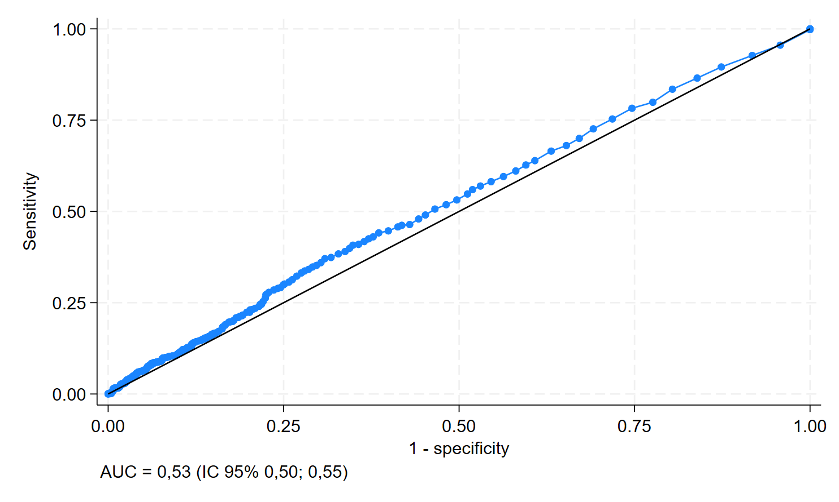

**Figura 4.** Curva ROC (*Received Operating Curve*) da capacidade preditiva do PCR/HDL para diagnóstico de doença carotídea.

# Determinar a relação da gravidade da doença carotídea com HDL/PCR.

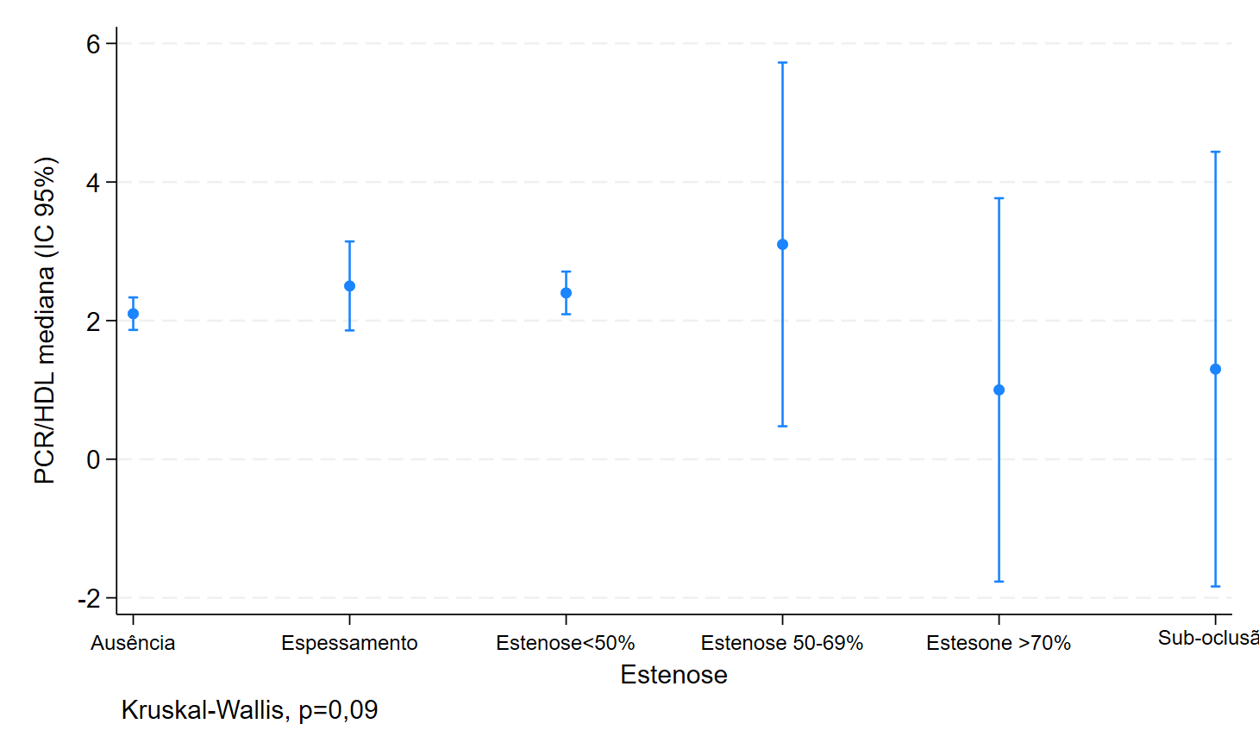**Figura 5.** Associação da gravidade da doença carotídea com o PCR/HDL

# Determinar se a associação de um ou mais fatores de risco com PCR/HDL é capaz de prever a existência de doença carotídea e sua gravidade.

**Figura 6.** Associação da presença de doença carotídea com o PCR/HDL ajustado por fatores de risco (Idade, sexo, HAS, DM, glicemia, triglicerídeos e dislipidemia).